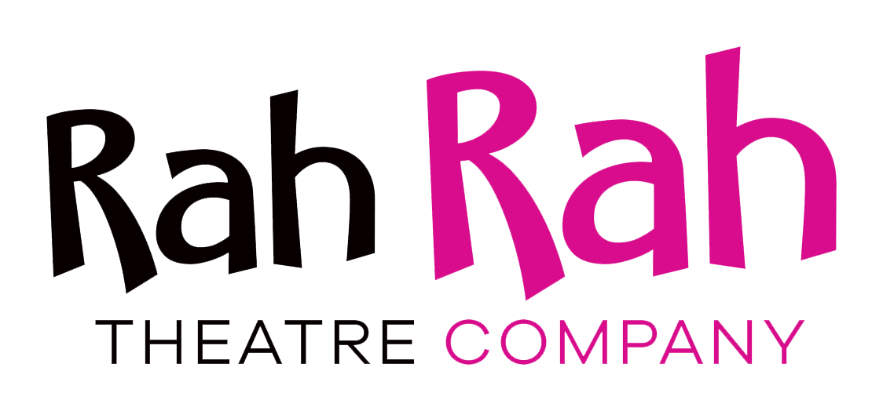
Rock Around the Clock – Summary and Evaluation
Original dates:
August – September 2021
Final dates due to Covid
August –October 2021
Overview of the Project
Clubs, activities, and volunteering, which older people previously were involved with, have been put on hold during the pandemic and friends and family have needed to stay away, leaving many older people feeling lonely and isolated. Age UK states: “We have heard from older people who said they had spent days without speaking to anyone and were left feeling unloved, unwanted, and forgotten. Some older people told us that they are feeling down, have lost pleasure and purpose in their lives, and feel as if every day is the same. We were sometimes told that there is nothing for them to look forward to and sadly a proportion even questioned whether their life is worth living.”

Rah Rah Theatre Company is a touring theatre company that has been working tirelessly through the pandemic to visit and perform to isolated vulnerable people in the community. They have performed in Care Home car parks, Sheltered Housing courtyards, as well as the doorsteps of vulnerable people in local communities. Rah Rah has been overwhelmed by the positive feedback they have received, for example: "My Dad, due to his dementia, has barely said a word since lockdown started. I watched with tears in my eyes as he sang along to all of Rah Rah’s songs. I will never forget this very special moment!"

Rah Rah received funding from the Culture Recovery Fund, Heart of Bucks (Community Foundation for Buckinghamshire), The R C Sherriff Trust and the Arnold Clark Community Fund to tour our much loved show, Rock Around the Clock, this Summer to community venues in London and the Home Counties. With this project Rah Rah brought some much needed joy and fun to their elderly audiences and the staff who have worked hard to adapt and cope during the pandemic. The tour has been a celebration for community groups and care homes as they re-open their doors.

The show we toured was a musical comedy and love story, set in the 50’s containing all the popular tunes of that time. The show has been devised to whisk audiences back to this memorable era allowing them to participate and reminisce. The cast comprised three professionally trained actors who have a wealth of experience performing in the community.

As part of the project Rah Rah also created an Activity Pack to leave as a lasting resource for our audiences to help them stay creative and active during lockdown and everyday life. The Activity Pack can be viewed online via the following link: https://www.rahrahtheatre.com/online-activity-pack

Rah Rah has worked for 20 years within the community and seen first-hand the truth of the Arts Council statement, “Getting involved in creative activities in communities reduces loneliness, supports physical and mental health and wellbeing, sustains older people and helps to build and strengthen social ties.”

We would like to thank the Culture Recovery Fund, Heart of Bucks (Community Foundation for Buckinghamshire), The R C Sherriff Trust and the Arnold Clark Community Fund for allowing us to continue our work this Summer.

Challenges we faced and how we overcame them
Unfortunately due to Covid we needed to reschedule over half the tour. This has been due to venues having cases of Covid, government guidelines lengthening lockdown and also our team of actors contracting Covid. Our admin team has had to put in an unprecedented amount of additional hours, some of which were unpaid. If we had not had the additional support of our marketing officer funded by the Culture Recovery Fund, none of this would have been possible as we would not have had sufficient man hours. Due to the unforeseen additional work, instead of creating a brand new Activities Pack, we developed and reused some of the previous material and included it in this year’s pack.
Tour Location
- The tour consisted of 105 shows in the following locations
- The borough of Elmbridge 5
- Buckinghamshire 20
- The borough of Kensington and Chelsea 6
- Venues across the rest of London and the Home Counties 74

Audience numbers
The average size audience we performed to was 30 due to Covid restrictions so the total number of audience members for the tour was 3150
Feedback
The following feedback is collated from a survey sent after the show. A full copy of the survey can be viewed here: https://www.rahrahtheatre.com/evaluation-forms
Did You Enjoy Rock Around the Clock? 100% Yes
Did you notice an improvement to the mood of the audience afterwards? 100% Yes
Is it beneficial for your service users to see live performances such as this? 100% Yes
Would you like to see more future projects like this? 96% Definitely would 4% Probably would.
Would you recommend us to other centres? 100% Yes
What did you like about the show most?
Some of the responses were as follows:
- It brought life to the centre after such a long period of being closed. It was the first entertainment our members had been able to enjoy since Covid. The performers were excellent and very friendly.
- The engagement with residents and remembering of names was impressive. Singing & dancing & energy was great!
- It was fun and interractive. The cast were very much in tune with our clients and reacted to them as individuals.
- Everything! Audience participation really made a difference and the actors were great at inclusion.
- The way Rah Rah theatre group drew the audience into the performance.
- The cast were very friendly and willing to engage with our residents, even the most disabled amongst them.
- interaction with the residents and they remembered resident’s names which made it more personal.
- Interaction with the audience was amazing.
- They talk and dance with the Residents

Please give us any specific feedback that you received from your clients or any quotes you would be happy for us to use in promotional material and/or online.
Some of the responses were as follows:
- There was a lot of effort put into this show, it had clearly been rehearsed well, great singing & acting, nice costumes, very amusing, entertaining throughout
- We have a lot of entertainment and one gentleman said you were the best we've ever had!
- What a great show, really enjoyed it and different from what we usually have.
- It was so entertaining and the look on Dad's face made our day! They went out of their way to include the Residents and remembered their names - I was so surprised when they called Mum by her first name - it was wonderful
- Very funny show, music and acting in one! A lovely, friendly group
- They loved it, they were able to identify the songs and sing along to them.
- Our members were over the moon to have the opportunity to get up and dance to the performance and have some fun interactions with the performers.
- Members of the audience asked how they could book the company for their own events they were that impressed.
- One resident said the choice of music was a perfect fit for age group at the home.
- The residents have asked that I book the panto and one resident said she hadn't seen her daughter laugh as much, ever.
- Rah rah been coming to the home for the last few years and the Residents look forward to seeing them each time

Any other comments you would like to say for only Rah Rah Theatre to see.
Thank you again for taking the time to complete these questions helping Rah Rah to continually grow and improve.
Some of the responses were as follows:
- The cast were absolutely brilliant . Lovely people, interacted with all our service users, were so friendly, great singers and dancers. After the show they took time to chat to our staff and service users. Will definitely use them again. Thank you all.
- Thank you so much for making the day so special!
- Thank you. Our residents enjoyed the show and appreciated having people coming to perform - the first time for a long while after lockdown.
- Keep going, fantastic work. Loved the way you were all so personable and chilled and picked the right people in the audience to include in jokes! I think many of us were crying with laughter at one point!
- We all really enjoy having the Rah Rah Theatre in and especially appreciate the interaction with residents and how actors remember their names
- it was lovely having live entertainment back in the home after such a long time, your guys were prompt, took time to listen to our residents and were funny. It was a great show and we will definitely have you back in for Christmas, Covid permitting of course.
- You do a great job and may you continue
- Always provide an excellent service
- Congratulations you are all very good actors

